
National College of Computer Studies
Paknajol, Kathmandu

Report on Currency Converter

Submitted by: Suraj Timsina Submitted to:
Programme: BSc. CSIT, 2nd Semester Janak Raj Joshi
Section: B
Roll No: 23
Email: surajtimsina321@gmail.com

Declaration
I hereby declare that the project work entitled “Currency Converter” submitted to Institute of Science and Technology, Tribhuvan University, Kathmandu. National College of Computer Studies, Kathmandu, is for the degree is submitted in partial fulfillment of requirements for the degree of Bachelor of Science in Computer Science and Information Technology (BSc.CSIT). This report contains all the original research and analysis with some information taken from other resources which are properly cited. This project work has not been submitted to any other university or institution for the award of any degree or diploma.

Suraj Timsina
Date: 5 Jan, 2024

Acknowledgement

This report is my assignment as a partial fulfillment of project work course for the requirement of Bachelor of Science in Computer Science and Information Technology (BSc.CSIT). I have taken this opportunity to express my respect and gratitude to my respected teacher Mr. Janak Raj Joshi for their valuable guidance in making this project a reality. I am thankful for their constant support and encouragement and valuable guidance and encouragement throughout this project completion period. I am also thankful to the lab teacher Kajol Ramtel for her help during the completion of the project. I would like to present my teachers gratitude for their guidance, good advice and honest reviews in this entire project session. Project has been completed under the intensive and genuine guidance of National College of Computer Studies.

Suraj Timsina
National College of Computer Studies
Date: 5 Jan, 2024

Abstract
My project on the topic “Currency Converter” is a project on C++ which allows the user to convert any amount of currencies to another currency. This small-scale project aims to provide an intuitive interface for users to input one currency amounts and instantly obtain the equivalent values in another currency. This application is a simple currency converter application designed to convert between various international currencies. The program prompts the user to select a currency from a predefined list and then calls corresponding conversion functions based on the user's choice. The supported currencies include US Dollar, Euro, Pound Sterling, Canadian Dollar, Japanese Yen, South Korean Won, Australian Dollar, Nepalese Rupee, Indian Rupee, Chinese Yuan, Swiss Franc, Russian Ruble, UAE Dirham, Malaysian Ringgit, Saudi Riyal, Qatari Riyal, and Pakistani Rupee. The program provides a user-friendly interface for currency conversion, making it accessible and practical for users who need to perform international currency exchanges.

Table of Contents
1. Introduction 1
2. Objective 1
3. LITERATURE REVIEW 1
4. METHODOLOGY 2
5. EXPERIMENT RESULT AND EXPECTED OUTCOME 3
6. SYSTEM IMPLEMENTATION 3
6.1. The Hardware used 3
6.2. The Software used 3
7. SYSTEM DESIGN AND DEVELOPMENT 3
7.1. MY SOURCE CODE 4
7.2. OUTPUT 6
8. Conclusion 7
9. User Manual 7
References 8

List of Figures
Figure 1: class currency 4
Figure 2: selection function 4
Figure 3: conversion function 5
Figure 4: main function 5
Figure 5: Output 1 6
Figure 6: Output 2 6

Abbreviations
IDE - Integrated Development Environment
VS - Visual Studio

Introduction
C++ s a high-level, general-purpose programming language. C++ has object-oriented, generic, and functional features, in addition to facilities for low-level memory manipulation. The currency converter converts amounts from one currency to another. Currency converters are generally useful to tourists, multinational businesses. The supported currencies include US Dollar, Euro, Pound Sterling, Canadian Dollar, Japanese Yen, South Korean Won, Australian Dollar, Nepalese Rupee, Indian Rupee, Chinese Yuan, Swiss Franc, Russian Ruble, UAE Dirham, Malaysian Ringgit, Saudi Riyal, Qatari Riyal, and Pakistani Rupee. It is useful tool which give the value of certain amount of one currency to be converted in to a different currency. [1]

Objective
The primary objectives of this project are as follows:
- User Interface: Display a welcome message along with the current date and time. Prompt the user to choose a currency for conversion from a list of options.
- Support Multiple Currencies: Design the program to handle a variety of foreign currencies and their exchange rates.
- Currency Conversion: Provide conversion options for various currencies, such as US Dollar, Euro, Pound Sterling, etc. Based on the user's selection, call specific functions to perform the currency conversion.
- Conversion Functions: Implement functions for each currency to handle the conversion process.
- Error Handling: Implement error-handling mechanisms to handle invalid inputs and prevent program crashes.
- Efficiency: Write efficient code that delivers quick results, even with frequent currency conversions.
- Encapsulation: Encapsulate the currency conversion functionality within a Currency class.

LITERATURE REVIEW
There has been several literature review and documentation regarding the work done in currency converter. Many programmers have tried to recreate this currency converter adding their own version to it. There were several creators who tried to create it. They used various functions and loops to create the currency converter. [2]

METHODOLOGY
  - Initialization and Setup:
- Import necessary libraries, such as iostream for input/output and ctime for handling time.
- Define a class (Currency) to encapsulate the currency conversion functions.
- Initialize a variable for storing the current time.
  - User Interface:
- Display a welcome message along with the current date and time.
- Prompt the user to choose a currency for conversion from a predefined list.
- Currency Conversion Functions:
- Implement functions for each currency to handle the conversion process.
- For each currency, perform the necessary calculations based on the user's input.
  - Input Handling:
- Use conditional statements (if-else) to check the user's input and call the appropriate conversion function.
- If the user enters an invalid option, display an error message and prompt for valid input using a goto statement.
  - Looping Mechanism:
- Use a do-while loop to allow the user to perform multiple currency conversions in a single session.
- After each conversion, ask the user if they want to use the application again. If yes, continue the loop; otherwise, exit.
  - Date and Time Display:
- Use the time function to fetch the current date and time and display it in the welcome message.
  - User Interaction:
- Take input from the user for currency selection and repeat the process based on user preference.
  - Thank-You Message:
- Display a thank-you message when the user decides to exit the application.
  - Encapsulation:
- Encapsulate the currency conversion functionality within a class to achieve better organization and modularization.
  - Time Handling:
- Utilize the time function to obtain the current time and format it for display in the welcome message.

EXPERIMENT RESULT AND EXPECTED OUTCOME
We expect to converter the currency of one country to another of any amount as per the user input. We also expect that the program is effortless to use and any amount of currency can be converted into the required country’s currency. Hence, we expect a simple and effective currency converter.

SYSTEM IMPLEMENTATION

The Hardware used
The implementation of a Currency Converter using C can be done on any hardware that supports the C programming language, including personal computers, laptops, and servers.

The Software used
The software used to develop this program is DEV C++ and its frameworks. There was no graphics used. Some popular C IDEs include Visual Studio, VS code, Code::Blocks, and Eclipse.

SYSTEM DESIGN AND DEVELOPMENT
For data storage, the amount of storage used to store the program's data, including any variables used by the program is the size of the data storage, that will depend on the size and number of the variables and files used by the program.

MY SOURCE CODE
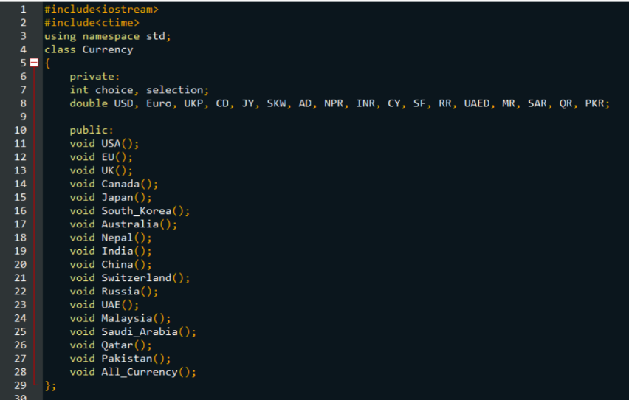
Figure 1: class currency

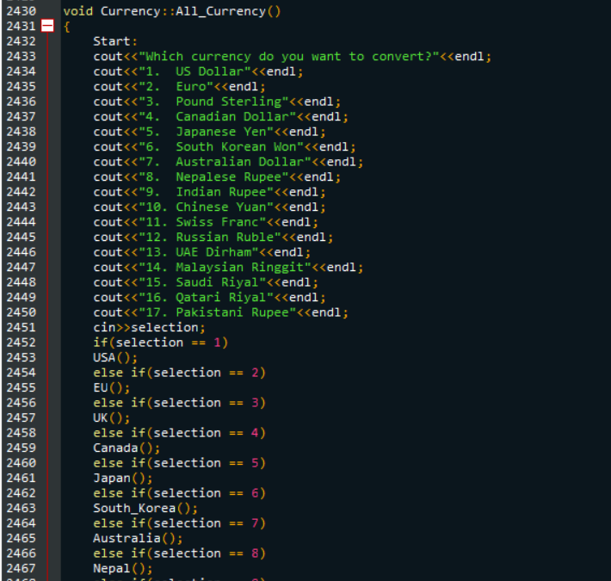
Figure 2: selection function
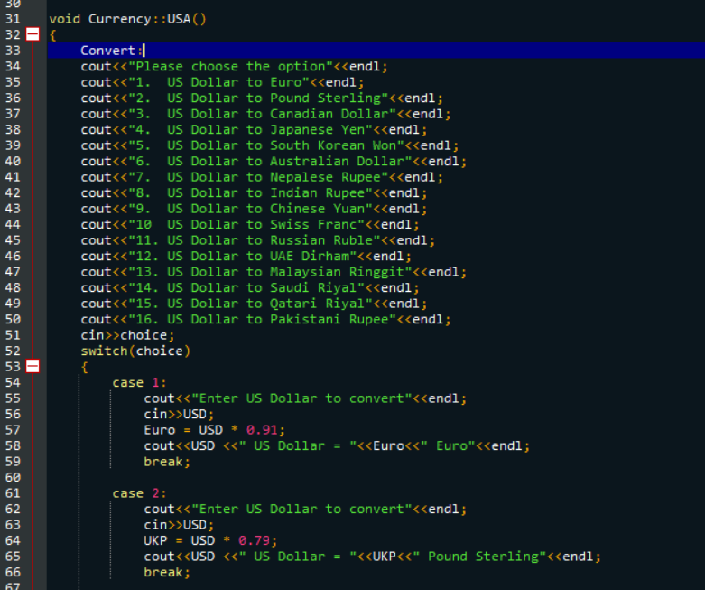
Figure 3: conversion function

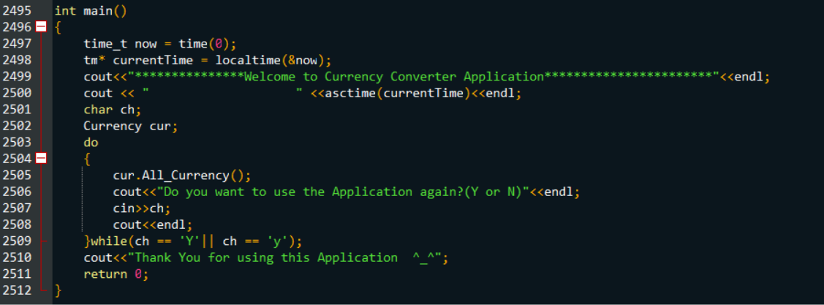
Figure 4: main function

OUTPUT
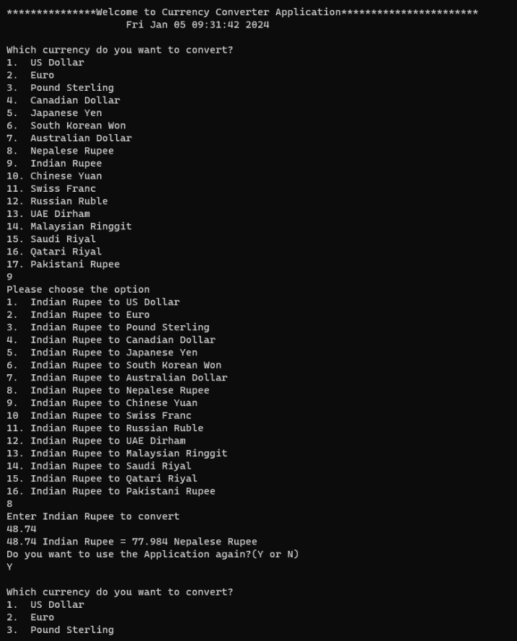

Figure 5: Output 1
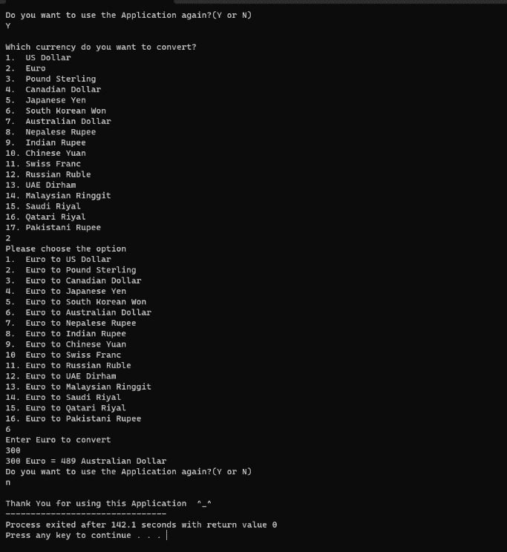

Figure 6: Output 2

Conclusion
In summary, the currency converter project has successfully implemented a user-friendly C++ application that allows users to convert between 17 different currencies. The program features a welcoming interface with current date and time display, accurate currency conversion logic, and a looping mechanism for multiple conversions within a single session. While the use of goto for error handling could be improved with modern control flow structures, the application achieves its core objectives, providing users with a functional tool for currency conversion. Future enhancements could focus on refining the user interface, incorporating exception handling, and potentially expanding the range of supported currencies. Overall, the project establishes a solid foundation for a currency converter application.

User Manual
The currency converter is very easy to use and can be used by anyone who has to convert their currencies. Here are some instructions on how to run this program:
- Run the application using a C compiler or IDE.
- Follow the on-screen instructions to select the desired currency conversion.
- Input the amount in the chosen foreign currency.
- The application will display the equivalent amount in Nepali Rupees.
- You can choose to perform another conversion or exit the application.
- If you want to use it again, press ‘y’ to use it again.

References

[1] | "Wikipedia," [Online]. Available: https://en.wikipedia.org/wiki/C%2B%2B.
[2] | [Online]. Available: http://studentsrepo.um.edu.my/3128/5/Chapter_2.pdf.

